ANALYSE OF REDDIT 2015-01-06

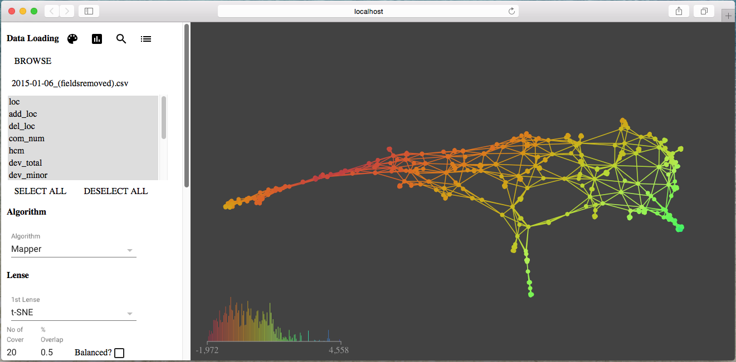

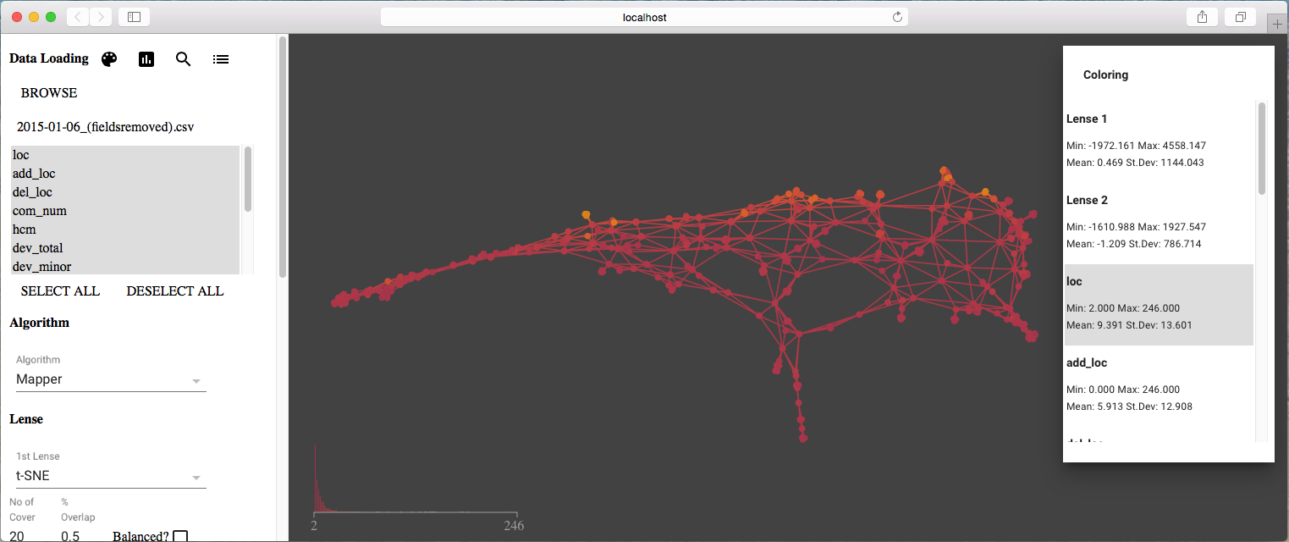

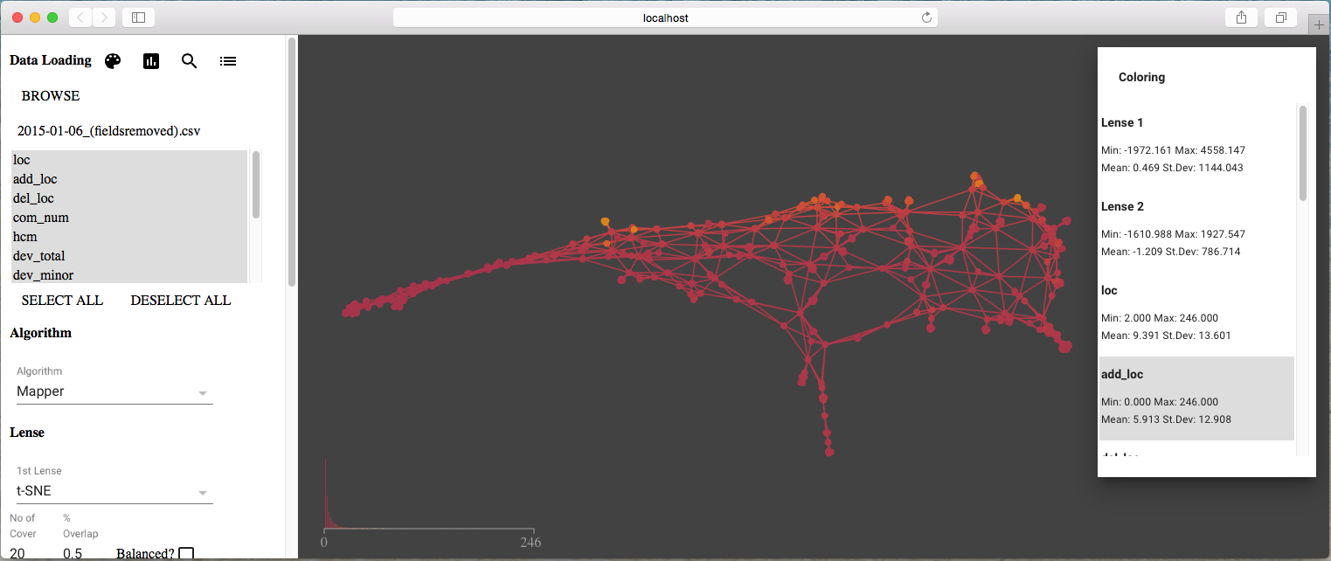

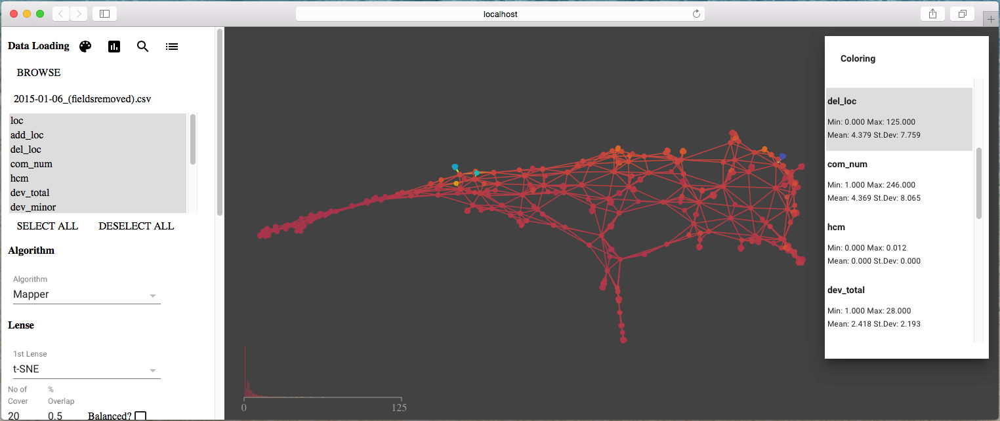

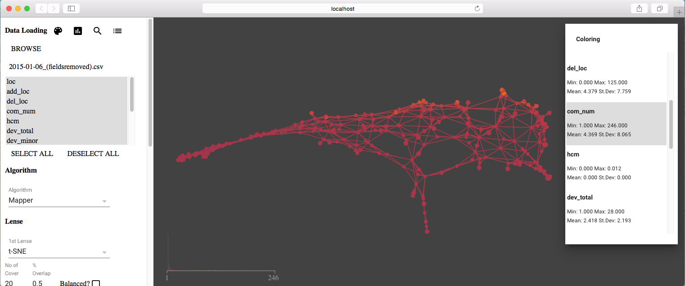

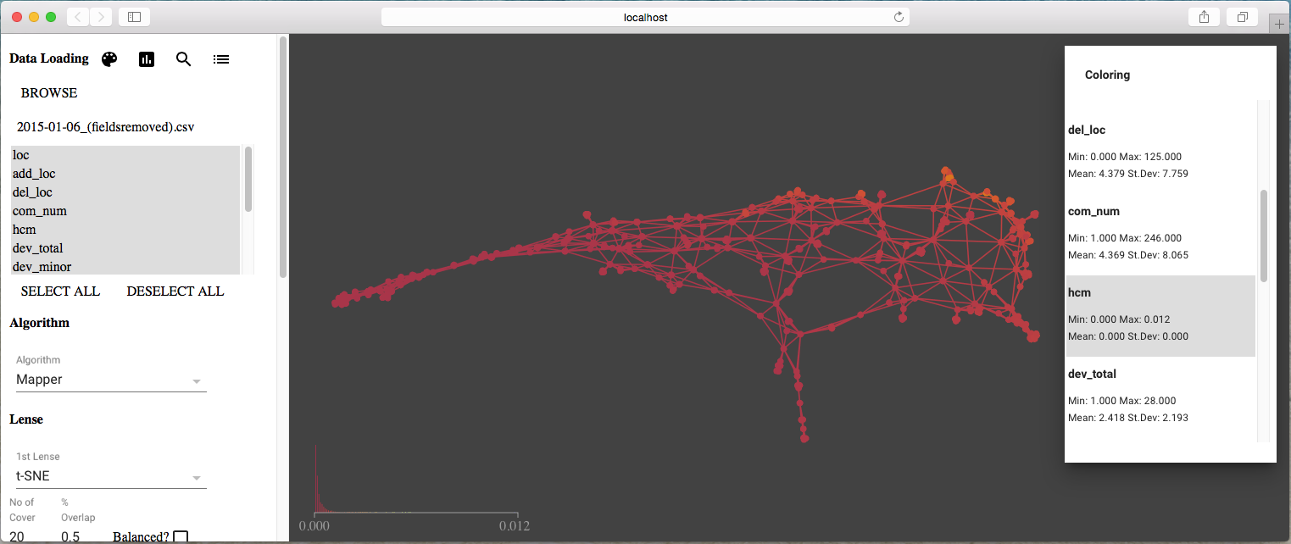

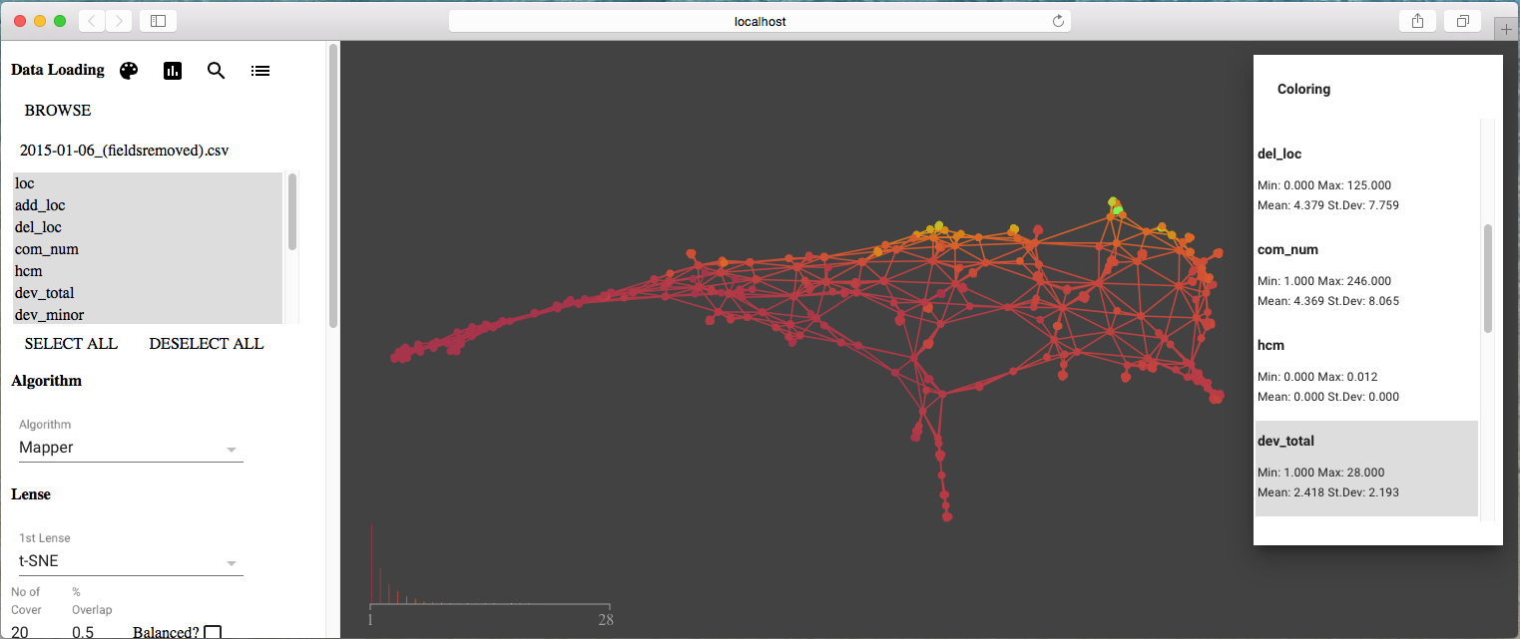

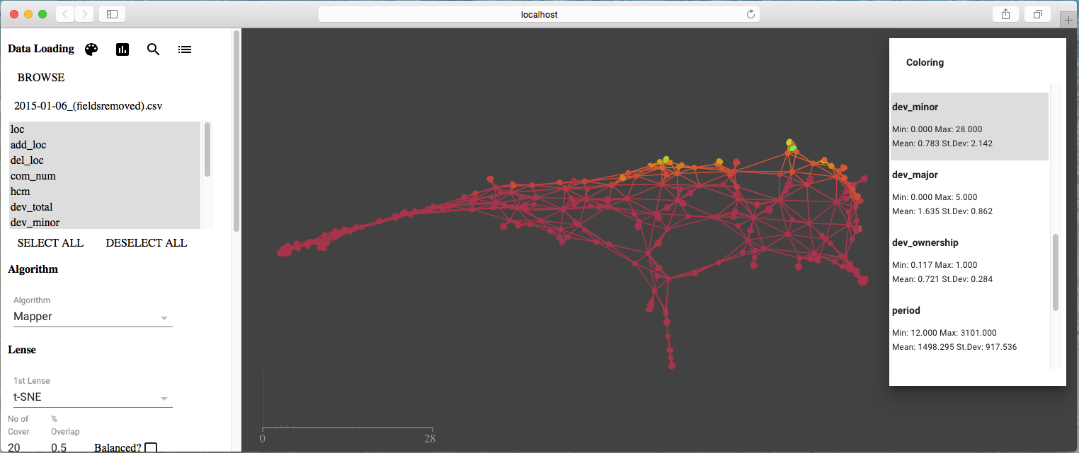

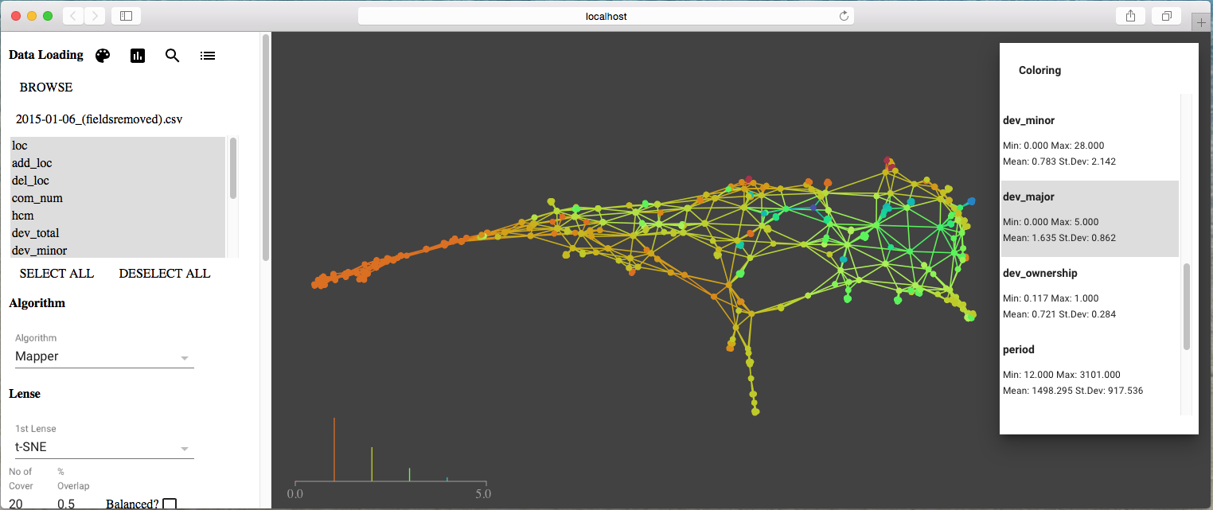

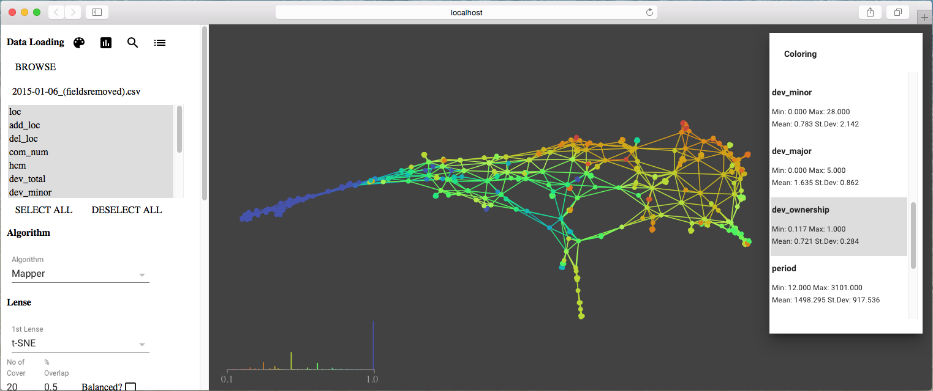

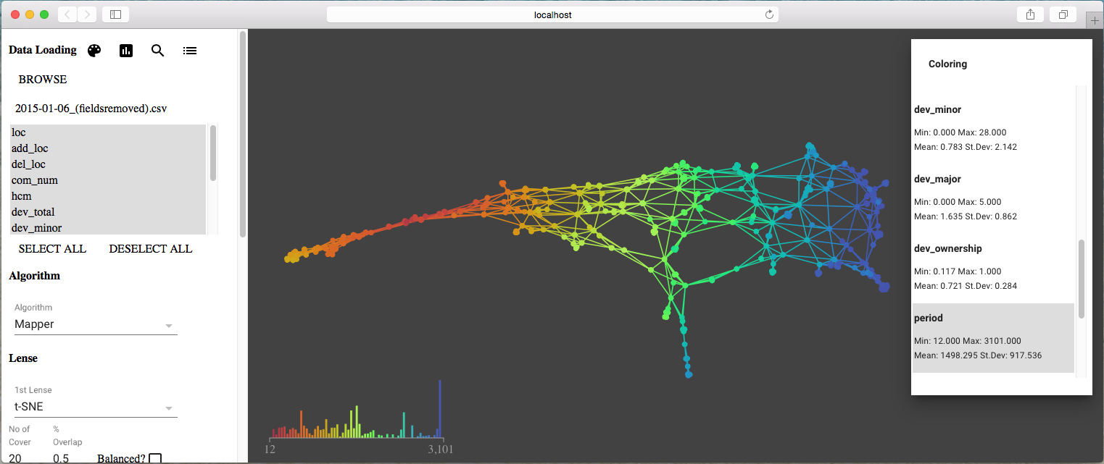

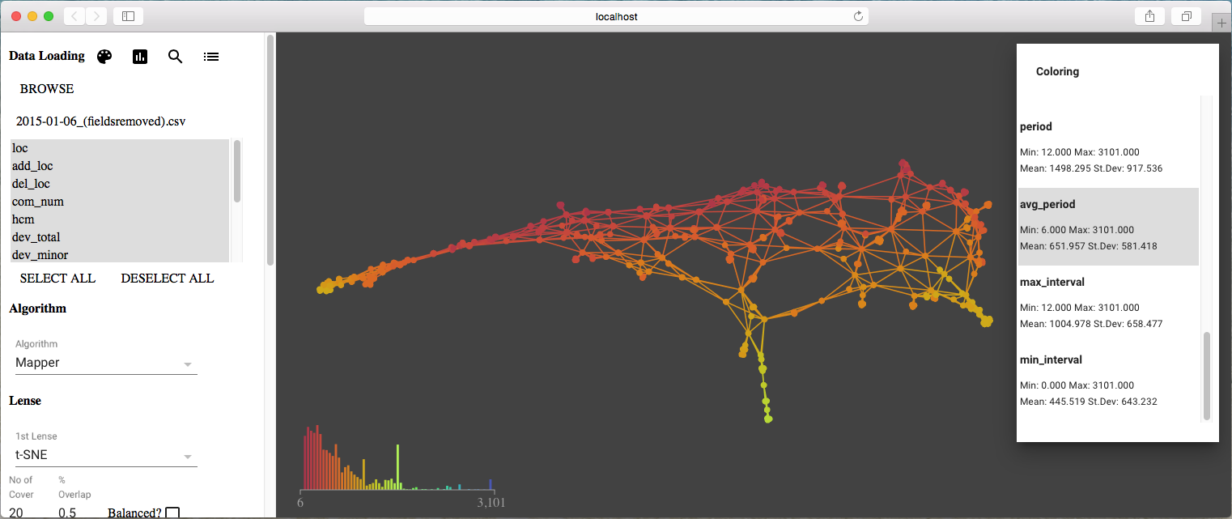

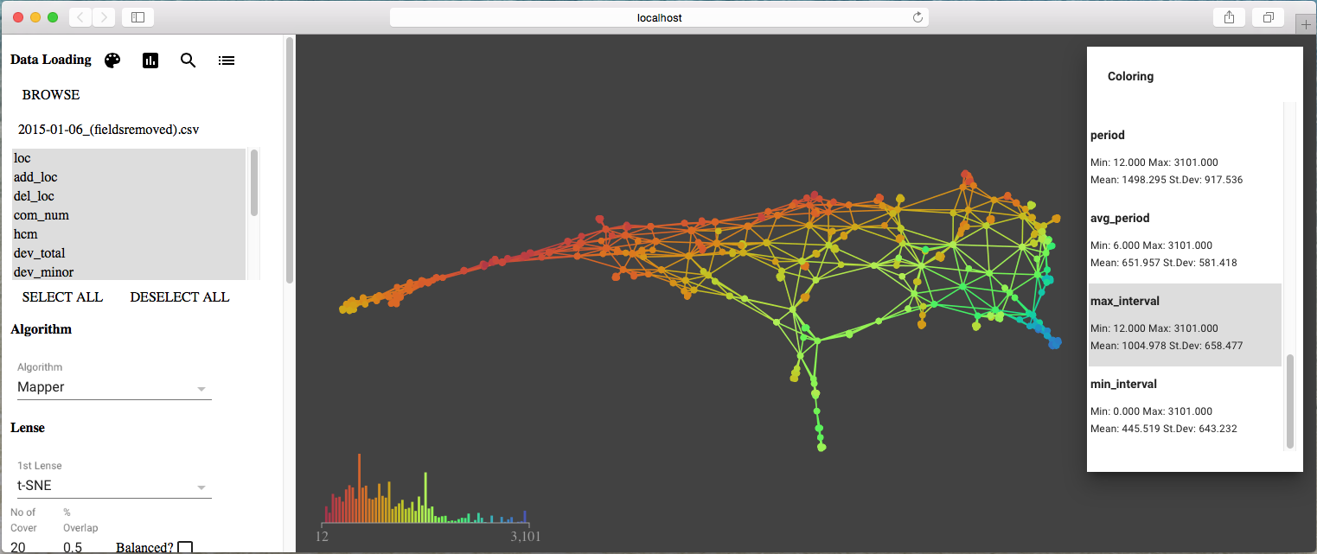

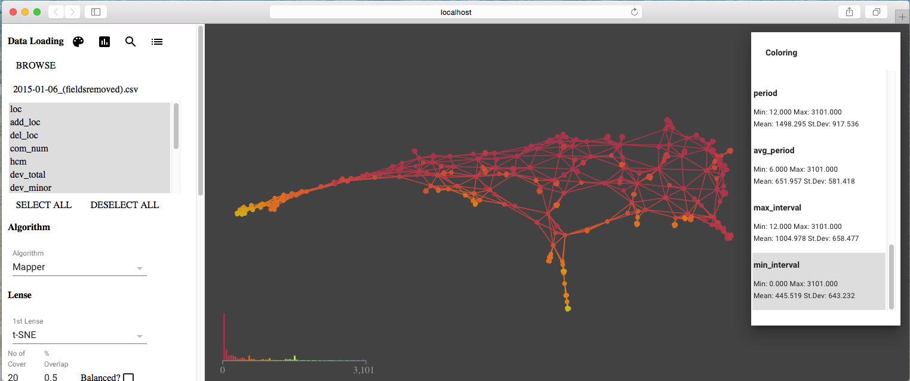

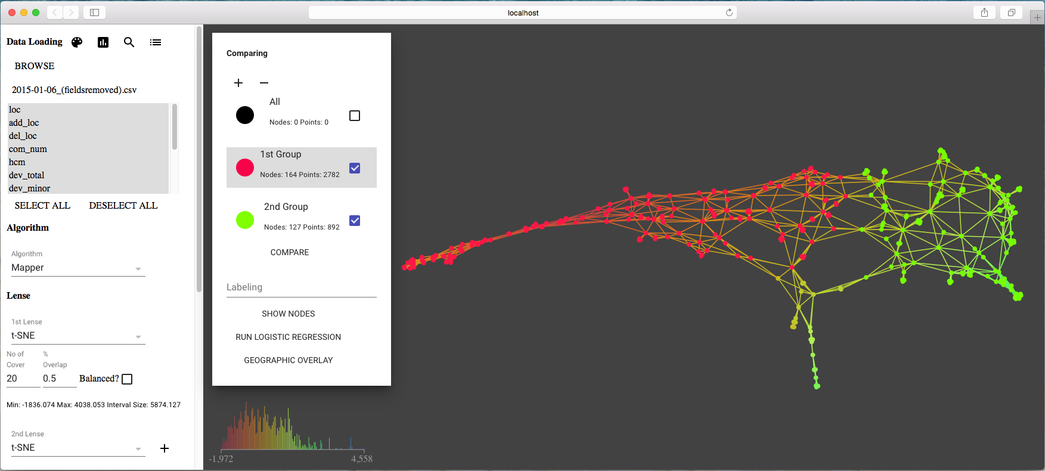

#### Analysis Result

|  |  |  |  |  |  |  |  |  |
| --- | --- | --- | --- | --- | --- | --- | --- | --- |
| **Variables** | **Group 1 min** | **Group 2 min** | **Group 1 mean** | **Group 2 mean** | **Group 1 median** | **Group 2 median** | **Group 1 max** | **Group 2 max** |
| loc | 2.0 | 2.0 | 9.088 | 13.105 | 6.0 | 7.0 | 106.0 | 246.0 |
| add_loc | 0.0 | 0.0 | 5.344 | 12.249 | 2.0 | 6.0 | 95.0 | 246.0 |
| del_loc | 0.0 | 0.0 | 4.296 | 8.048 | 2.0 | 5.0 | 106.0 | 125.0 |
| com_num | 1.0 | 3.0 | 3.453 | 10.192 | 2.0 | 7.0 | 74.0 | 246.0 |
| hcm | 0.0 | 0.0 | 0.0 | 0.001 | 0.0 | 0.001 | 0.002 | 0.012 |
| dev_total | 1.0 | 1.0 | 2.074 | 4.808 | 2.0 | 4.0 | 16.0 | 28.0 |
| dev_minor | 0.0 | 0.0 | 0.455 | 2.636 | 0.0 | 2.0 | 15.0 | 28.0 |
| dev_major | 0.0 | 0.0 | 1.619 | 2.173 | 1.0 | 2.0 | 5.0 | 5.0 |
| dev_ownership | 0.167 | 0.117 | 0.751 | 0.429 | 0.875 | 0.4 | 1.0 | 1.0 |
| period | 12.0 | 1770.0 | 973.743 | 2779.751 | 931.0 | 2994.5 | 2403.0 | 3101.0 |
| avg_period | 6.0 | 12.0 | 407.033 | 471.185 | 345.0 | 431.0 | 1067.0 | 1033.0 |
| max_interval | 12.0 | 166.0 | 665.29 | 1286.88 | 602.0 | 1210.0 | 1883.0 | 2877.0 |
| min_interval | 0.0 | 0.0 | 242.311 | 62.383 | 97.0 | 6.0 | 1067.0 | 737.0 |